Develop a vb project to move the items between list and combo boxes

Formdesign:

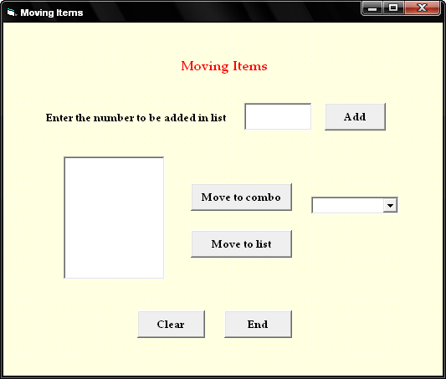

Properties:

Controls | Name | Caption
Text1 | Text1
List1 | List1
Combo1 | Combo1
Command1 | Cmdadd | Add
Command2 | cmdmovetocombo | Move to combo
Command3 | cmdmovetolist | Move to list
Command4 | Cmdclear | Clear
Command5 | Cmdend | End

1.Moving Items
Aim:
To develop a vb project to move the items between list and combo boxes

Coding:
Dim a, i, j As Integer

Private Sub cmdadd_Click()
a = Text1.Text
List1.AddItem (a)
Text1.Text = " "
End Sub

Private Sub cmdmovetocombo_Click()
For i = 0 To List1.ListCount
Combo1.AddItem (List1.List(i))
Next i
List1.Clear
End Sub

Private Sub cmdmovetolist_Click()
For i = 0 To Combo1.ListCount
List1.AddItem (Combo1.List(i))
Next i
Combo1.Clear
End Sub

Private Sub cmdclear_Click()
Text1.Text = " "
List1.Clear
Combo1.Clear
End Sub

Private Sub cmdend_Click()
End
End Sub

Output:

